November Newsletter
Maghribi and Raffa’s News
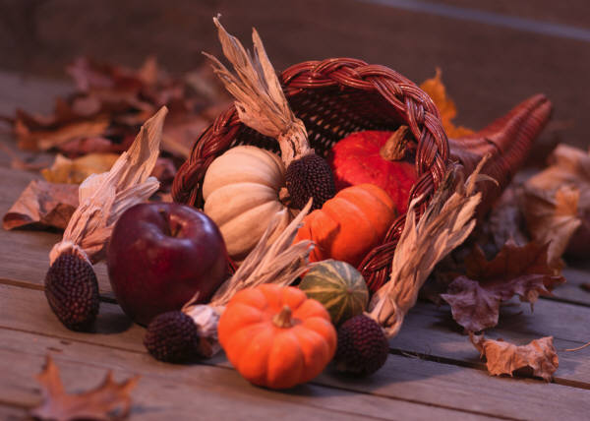

Upcoming Events

November 14
Thanksgiving Family Lunch

November 15

Turkey Bingo

November 17-25
Thanksgiving Break

Important Announcements:
***A quick “thank you” to all of you for checking out my blog on a regular basis.
***It is very important that they bring home their standards based math and writing journals to help them with the standards being taught on a given day.

Powers Ferry Elementary-4th Grade Room 406
770-578-7936
Dana.maghribi@cobbk12.org
Robin.raffa@cobbk12.org
Dear Parents,
This newsletter will serve as our monthly communication as to the “Happenings” inside our classroom, here at the school and outside in the community. The newsletter will also include overall learning topics in each subject area that we will be covered during the month. Just a follow up to conferences, your child is able to bring their standards based journals and their textbooks home with them each and every night.
I want to wish your family a Happy Thanksgiving. It is my favorite holiday because it provides an opportunity to reflect upon what we are thankful for in our lives. I want you to know how thankful I am that I get to have a positive impact on the life of your child. I hope your family has a wonderful Thanksgiving holiday.
Ms. Maghribi and Mrs. Raffa

Math: Students will be focusing on the following area:
*Multiplication and Division of Whole Numbers
Writing: Persuasive and Creative Writing.
Social Studies: New Nation
Science: Ecosystems

